### Logo2001

**YEAR 12 CHEMISTRY ATCHE**

**TEST 3**

**Redox reactions and electrochemical cells**

**/45**

**Recommended time: 40 minutes**

Name: _____________________________________________________

Teacher: _____________________________________________________

This test consists of two (2) parts.

**Part 1:** Multiple choice style consisting of TEN (10) questions.

Each question is worth 1 mark.

Write your answers in the **Multiple Choice Answer Sheet** provided.

Attempt ALL Questions.

**Part 2:** Short and/or Extended Answer questions

Write all answers in the spaces provided.

The marks allocated to each question are shown at the foot of each question.

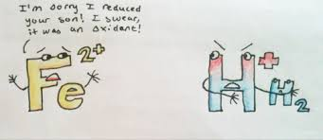

**MULTIPLE CHOICE ANSWER SHEET**

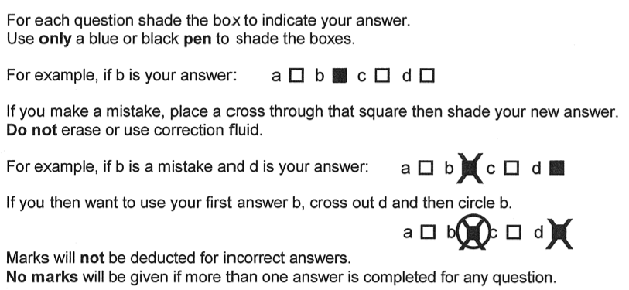



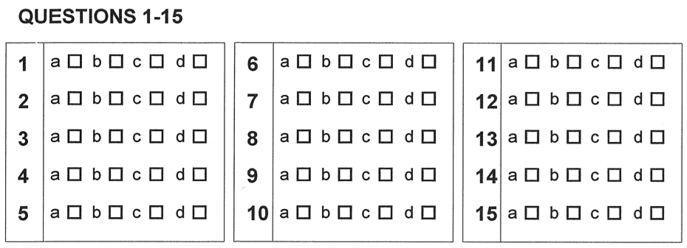

**PART 1: Multiple Choice 10 marks**

Write your answers on the Multiple Choice grid on the front page.

1. Mr Taylor is very pleased with his Holden car. Holden cars, on account of not being Fords, are often associated with rust. Which of the following treatments would be **least likely** to help prevent the steel in a “Holden Commode” brand of car from rusting?

(a) Storing it under water

(b) Storing it under water containing 0.1M potassium hydroxide

(c) Painting all its metal surfaces to exclude oxygen

(d) Storing it under water containing 0.1M sodium hydrogen sulfate.

2. Concentrated nitric acid (HNO3) is able to act as an oxidising agent. Which one of the following equations illustrates this ability?

(a) NaOH + HNO3 → NaNO3 + 2H2O

(b) Cu + 4 HNO3 → Cu(NO3)2+ 2H2O + 2NO2

(c) MgCl2 + 2HNO3 → Mg(NO3)2 + 2HCl

(d) NH3 + HNO3 → NH4NO3

3. Which one of the following is/are redox reactions?

1. Zn(s) + 2H+(aq) + 2NO3-(aq) → Zn(NO3)2(aq) + 2NO2(g) + 2H2O(l)
2. Ba2+(aq) + SO42-(aq) → BaSO4(s)

iii. CaCO3(s) → CaO(s) + CO2(g)

iv. 2Na(s) + 2H2O(l) → 2NaOH(aq) + H2(g)

v. Fe(s) + Cu2+(aq) → Cu(s) + Fe2+(aq)

(a) i and ii only

(b) ii and v only

(c) ii, iii and iv

(d) i, iv and v

4. A sample of molten calcium bromide (CaBr2) was electrolysed. Which of the following would occur within the electrolytic cell?

(a) Bromine forms at the cathode

(b) The Ca2+ ions move towards the anode

(c) The Br - ions are reduced

(d) Calcium forms at the negative electrode

5. One classical example of an electrochemical cell is the Daniel cell

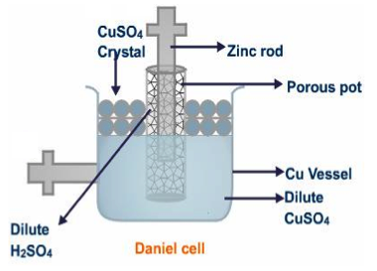

The positive electrode in the Daniel cell above is the

(a) zinc rod

(b) copper vessel

(c) porous pot

(d) CuSO4 crystal

6. The half equations and standard reduction potentials for the ions Cu+(aq) and Cu2+(aq) are as follows:

Cu+(aq) + e- → Cu(s) Eo = + 0.52 V

Cu2+(aq) + 2e- → Cu+(aq) Eo = + 0.15 V

The standard potential, in Volts, for the disproportionation reaction: **2Cu+(aq) → Cu2+(aq) + Cu(s)** is

(a) - 0.67 V

(b) - 0.37 V

(c) + 0.37 V

(d) + 0.67 V

7. In an experiment performed at standard conditions, a student made the following observatory notes:

i. clean metal A did not react with 1.0 mol/L solution containing B2+ ions

1. clean metal B dissolved in 1.0 mol/L solution containing C2+ ions and crystals of C appeared
2. clean metal C did not react with 1.0 mol/L solution containing A2+ ions

According to the notes, the order of strength as an oxidising agent is

(a) C2+ ions > A2+ ions > B2+ ions

(b) C2+ ions > B2+ ions > A2+ ions

(c) A2+ ions > B2+ ions > C2+ ions

(d) B2+ ions > A2+ ions > C2+ ions

8. An electrochemical cell made from the following reaction has a voltage reading of 1.03 V

Cl2 + 2V3+ + 2H2O → 2VO2+ + 4H+ + 2Cl-

What is the standard reduction potential for the reaction where VO2+ is converted to V3+?

(a) - 3.05 V

(b) - 0.33V

(c) + 0.33 V

(d) + 3.05V

9. Consider a zinc/copper electrochemical cell containing copperelectrode in 1.0 molL-1 copper (II) sulfate solution and zinc metal in 1.0 molL-1 Zn(NO3)2 solution.

Which of the following saturated solutions at 25oC and atmospheric pressure can be used as a salt bridge?

(i) NaNO3 (ii) KBr (iii) Na2CO3

(a) i only

(b) i and ii only

(c) i and iii only

(d) all three solutions are suitable

10. Four metals **Pb**, *x,* *y* and *z*, were connected in pairs and the voltage was recorded.



The results obtained are set out in the table below. What is the order of increasing ease of oxidation of the metals?

|  |  |  |
| --- | --- | --- |
| ***Negative terminal*** | ***Positive terminal*** | ***Voltage (V)*** |
| **Pb** | *x* | 0.35 |
| *y* | **Pb** | 1.10 |
| *z* | **Pb** | 2.60 |

(a) *z*, *y*, Pb, *x*

(b) Pb, *x*, *y*, *z*

(c) *x*, *y*, Pb, *z*

(d) *x*, Pb, *y*, *z*

**PART 2 : SHORT ANSWER 34 marks**

Answer each of the following questions in the space provided.

**Question 1 4 marks**

Write balanced equations for the reactions that occur in the following experiments. Use **ionic** equations where appropriate. In each case describe observations such as colour changes, precipitate formation (give the colour), or gas evolution (give colour or describe as colourless) resulting from the chemical reactions. **Include** state subscripts.

|  |
| --- |
| (a) A strip of chromium metal is placed in a 1.0 molL-1 solution of cobalt (II) nitrate solution. |
| Equation: **2Cr(s) + 3Co2+(aq) → 3Co(s) + 2Cr3+(aq) 1 mark** |
| Observation: **Pink solution turns to green. Fresh grey deposit on surface of chromium metal. 1 mark** |

[2 marks]

|  |
| --- |
| (b) A small quantity of bromine water (Br2(aq)) is added to 10.0 mL of 1.0 molL-1 sodium iodide solution. |
| Equation: **Br2(aq) + 2I-(aq) → 2Br -(aq) + I2(aq) 1 mark** |
| Observation: **Orange solution turns brown. 1 mark** |

[2 marks]

**Question 2 6 marks**

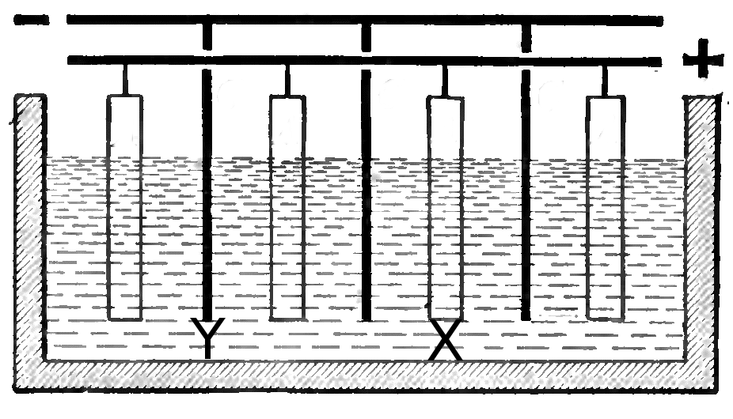

The diagram above represents a system used to produce pure copper from slabs of “blister copper”. Blister copper is obtained by heating copper ore and powdered coal in air, and then allowing the molten metal to form electrodes which are then placed in a solution of copper sulfate/sulfuric acid.

1. Which electrode is the cathode in this cell (positive or negative)? [1 mark]

|  |
| --- |
| Negative |

1. Which copper bars will get thicker during the course of this process – (X or Y)? [1 mark]

|  |
| --- |
| Y |

1. Would you expect electrolyte to become darker, lighter, or to remain the same colour as the process proceeds? Explain your answer. [2 marks]

|  |
| --- |
| **Same (1): as Cu 🡪 Cu2+ occurs at the anode, and equal amount of Cu2+ 🡪 Cu at the cathode is formed** |
|  |
|  |

1. During the course of this process, a solid forms under the blister copper electrode. This sludge consists of a range of other metals. Would you expect those metals to have a greater or lesser standard reduction potential than copper? Explain your answer. [2 marks]

|  |
| --- |
| **Greater (1). They for a metallic sludge, meaning they are still reduced so they require a greater cell voltage to reduce. (or similar. relate metal or reactivity to voltage) (1)** |
|  |
|  |
|  |

**Question 3 14 marks**

The following diagram represents an electrochemical cell based on chromium and nickel electrodes in 1.0 molL-1 electrolyte solutions . A porous barrier separates the two half cells but allows ions to migrate between them. The cell operates under standard conditions.

Cr(NO3)3 solution

NiSO4

solution

**Ni**

# Cr

* 1mark

cathode

Anode

(a) Write the anode, cathode and overall redox equation for the cell above. [3 marks]

Anode: **Cr(s) → Cr3+(aq) + 3è 1 mark**

Cathode: **Ni2+(aq) + 2è → Ni(s) 1 mark**

Overall: **2Cr(s) + 3Ni2+(aq) → 2Cr3+(aq) + 3Ni(s) 1 mark**

(b) On the diagram, label the electrode that is the anode. [1 mark]

(c) Draw an arrow in the box provided to show the direction of the electron flow in the wire. [1 mark]

(d) What is the maximum theoretical EMF (voltage) that can be generated? (Assume 1.0 mol L−1 concentrations and standard conditions) [1 mark]

**Cell EMF = (- 0.24) + 0.74 = + 0.50 V 1 mark**

(e) Which anion (negative ions) will migrate through the porous barrier? [1 mark]

**Sulfate ion (SO42-) 1 mark**

(f) State two (2) changes that will be observed. [2 marks]

**Cr electrode becomes thinner**

**Ni electrode becomes thicker (or fresh grey deposit forms on surface)**

**Chromium nitrate solution becomes darker green**

**Nickel sulfate solution becomes lighter green any two for 2 marks**

(g) What will be observed if the porous barrier is removed and the solutions become mixed? [2 marks]

* **Cr electrode starts to dissolve and a fresh grey coating forms (due to nickel deposits)**
* **Nickel electrode stops becoming thicker (due to direct reaction between nickel ion and chromium electrode)**
* **Current now stops (assuming an ammeter/voltmeter/globe in the circuit)**

**any two for 2 marks**

(h) The standard reduction potential for nickel metal is (- 0.24 V). Explain the role of the hydrogen half-cell in determining this value. Comment on the significance of the negative value. You may use diagrams to aid your explanation. [3 marks]

* **Recognition that the hydrogen half-cell is assigned an E° of 0 V or reference cell (or similar). 1 mark**
* **Recognition that cadmium half-cell E° is determined relative to the hydrogen half-cell. 1 mark**
* **Recognition that the negative value means that the cadmium half-cell is anodic relative to the**

**hydrogen half-cell (or electrons flow from the cadmium to the hydrogen cell or the relative number of**

**electrons in the cadmium half cell is higher than that of hydrogen reference cell). 1 mark**

* **Typical diagram to support answer**

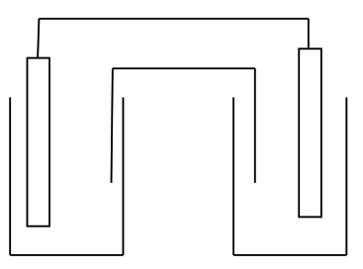

**Question 4 7 marks**

Blood glucose sensors have dramatically improved the quality of medical care of people with diabetes, a disease in which a persons’ body is unable to control their blood glucose concentration.

The chemistry of these sensors involves a two reactions:

In **Reaction 1**, glucose (C6H12O6) reacts with oxygen to form gluconolactone (C6H10O6) and hydrogen peroxide (H2O2).

In **Reaction 2**, the gluconolactone and the hydrogen peroxide react together to form glucuronic acid (C6H10O7) and water.

(i) Write balanced half equations, and then the overall balanced equation for **Reaction 1**. [3 marks]

|  |  |
| --- | --- |
| Oxidation half reaction | C6H12O6 🡪 C6H10O6 + 2H+ + 2e- ( 1 mark) |
| Reduction half reaction | 2H+ + O2 + 2e- 🡪 H2O2 ( 1 mark) |
| Overall balanced reaction | C6H12O6 + O2 🡪 C6H10O6 + H2O2 ( 1 mark) |

(ii) Write balanced half equations, and then the overall balanced equation for **Reaction 2.** [3 marks]

|  |  |
| --- | --- |
| Oxidation half reaction | C6H10O6 + H2O 🡪 C6H10O7 + 2H+ + 2e- ( 1 mark) |
| Reduction half reaction | 2e- + H2O2 + 2H+ 🡪 2H2O ( 1 mark) |
| Overall balanced reaction | C6H10O6 + H2O2 🡪 C6H10O7 + H2O ( 1 mark) |

(iii) Which atom changes its’ oxidation number in glucose? [1 mark]

|  |
| --- |
| carbon |

**Question 5**   
Steel can be electroplated with chromium in order to improve its appearance and protect it from corrosion.

Chromium plates well from an acidic solution, so the electrolyte used in the cell is usually a solution of potassium dichromate, K**2**Cr**2**O**7**, in sulfuric acid.



The half reactions which occur in the cell can be represented as follows:

Cr**2**O**72-(aq)** + 14H**+(aq)** + 12e**-**  2Cr**(s)** + 7H**2**O**(l)**

2H**2**O**(l)**  O**2(g)** + 4H**+(aq)** + 4e**-**

(a) In the above cell, which electrode (positive or negative) is the cathode and which is the anode? [1 mark]

|  |
| --- |
| Negative=cathode positive = anode (accept if labelled on diagram) |

(b) Write a balanced equation to represent the overall reaction in the cell. [1 mark]

|  |
| --- |
| Cr**2**O**72-(aq)** + 2H**+(aq) +** 6H**2**O**(l)** 🡪 3O**2(g) +** 2Cr**(s)** + 7H**2**O**(l)** |
|  |

(c) Would an iron door knob left to soak in a solution of potassium dichromate in sulfuric acid eventually become coated with chromium? Why or why not? [2 marks]

|  |
| --- |
| No. (1) The iron would be oxidised in preference to the water (1/2), as that half reaction has a lesser standard redox potential than the water (1/2). |
|  |
|  |

**End of Test. Now make sure you complete the Comprehension Task.**